Dependent-Samples t Test – Example 2 (Romantic Love) – Answer Key

Aron et al. (2005) were interested in examining the brain systems involved in human romantic love. They wanted to determine whether romantic love causes a change in neuronal activity in a part of the brain called the caudate. They recruited participants who had recently fallen madly in love. Participants were asked to bring one picture of their love interest and one picture of a familiar, neutral person of the same age and sex as their love interest. Participants then had fMRI scans that measured activity in the caudate while they looked at each picture for 30 seconds.

Step 1. State your hypotheses.
a. Is it a one-tailed or two-tailed test? Two-tailed

b. Research hypotheses
H_{A}: There will be a different amount of neuronal activity in the caudate when the participants
look at a picture of their beloved compared to when they look at the neutral picture.

H₀: There will be no difference in the amount of neuronal activity in the caudate when the
participants look at a picture of their beloved compared to when they look at the neutral picture.

c. Statistical hypotheses
H_{A}: µ_{D} ≠ 0

H₀: µ_{D} = 0
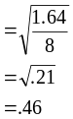
Step 2. Set the significance level ➔ α = .05 Determine t_{crit}. t_{crit} = + 2.262 df = 9

Step 3. Select and compute the appropriate statistical test.
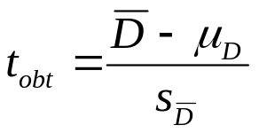
Beloved | Control | D
8 | 8 | 0 | -1.4 | 1.96
8 | 2 | 6 | 4.6 | 21.16
7 | 5 | 2 | .6 | .36
3 | 4 | -1 | -2.4 | 5.76
9 | 8 | 1 | -.4 | .16
4 | 4 | 0 | -1.4 | 1.96
5 | 4 | 1 | -.4 | .16
4 | 3 | 1 | -.4 | .16
2 | 0 | 2 | .6 | .36
8 | 6 | 2 | .6 | .36
ΣX₁ = 58 | ΣX₂ = 44 | ΣD = 14
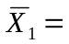5.8 | 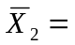4.4 | 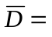 1.4 |  | = 32.4
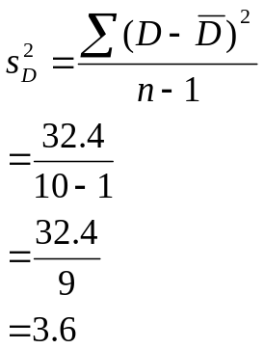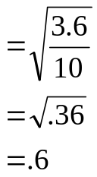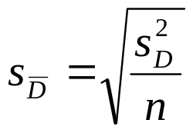
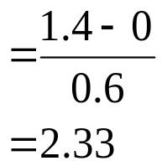

Step 4. Make a decision. Determine whether the value of the test statistic is in the critical region. Draw a picture. Label t_{crit} and t_{obt}.
Is z_{obt} in the critical region? Yes
Should you reject or retain the H₀? Reject
t_{obt} = 2.33
t_{crit} = 2.262
t_{crit} = -2.262

Step 5. Report the statistical results.

t(9) = 2.33, p < .05

Step 6. Write a conclusion.

Activity in the caudate was significantly higher when participants were looking at a picture of their beloved (M = 5.80) than when they were looking at the neutral picture (M = 4.40), t(9) = 2.33, p < .05.

Step 7. Compute the estimated d.

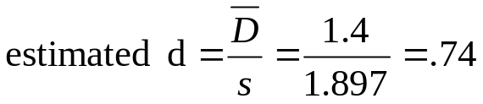
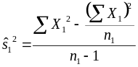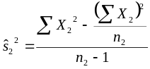

Step 8. Compute r² and write a conclusion.

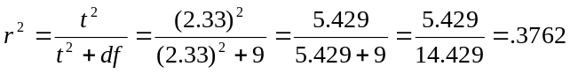

The picture participants looked at accounts for 37.62% of the variance in the difference scores for caudate activity.

